Toiletry Case

User Manual

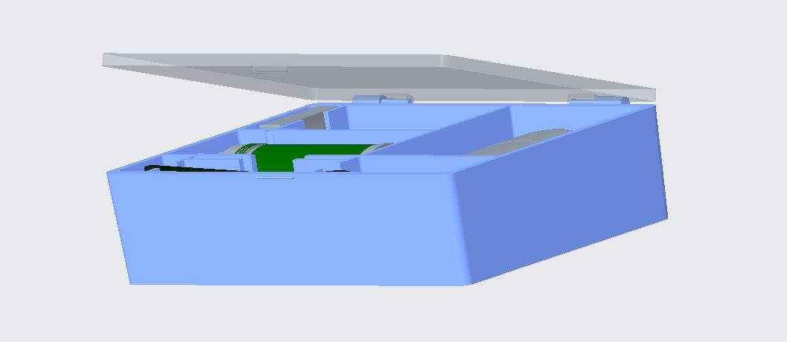

Sahil Shah, Arjun Phadke, Sam Chandler, William Himelspack

## Toiletry Case

Table of Contents

Parts List…………………………………………………………………………………….3

Assembly & Use…………………………………………………………………6

Maintenance……………………………………………………………………………….7

Warranty Information……………………………………………………8

Service Center……………………………………………………………………….9

## 

## 

## 

## 

## 

## 

## 

Parts List

The Toiletry Case consists of 4 pieces made from polyethylene terephthalate and is put together in our factories. Components are plastic welded and should not be disassembled.



**Case Lid**

* 9.66 in x 6.16 in x 0.25 in
* Translucent with 66% transparency
* Snap fit latch on front attaches to the case body to keep the case closed.
* Built from lightweight plastic



**Case Body**

* 9.5 in x 6 in x 2.3 in
* 2 degree draft with top .16 in longer and wider than base
* Outer body shell is .2 in thick
* Inside ribs are .12 in thick
* Light blue color
* Compartmented to hold various items
* Built from lightweight plastic



**Hinge Dowel**

* 1.5 in long and 0.125 in is diameter
* 2 included in the toiletries case
* One for each hinge
* Light blue color

Assembly & Use

The toiletry case has been pre-assembled in our factory for your convenience. The toiletry box consists of two shells and two pins. These pins have been plastic welded into place so you don’t have to worry about them falling out. Once the case has been unboxed your toiletries can be placed inside and the lid can be closed.

The operation of the toiletry box is very simple. In order to open the latch, place your finger under the tab and pull out and up. Closing the latch is even simpler, as it will lock itself when the box is closed. The box has been divided up into separate compartments for all of your essential toiletries.

Maintenance & Cleaning

* The Toiletry Case is subject to become unsanitary because of the nature of the objects this device is expected to carry. It is designed to combat uncleanliness by having an elevated compartment specifically designed to keep your toothbrush.
* One key point of interest when it comes to keeping the Toiletry Case clean is the inside corners of the case that have rounded edges. A simple way to prevent bacteria build up in these areas is to apply a disinfecting wet wipe to each individual compartment.
* Repeating this process on the translucent lid and the plastic welded hinges is also recommended as to keep the product’s lid functional and able to open smoothly.

Warranty Information

We are offering a 30 day money back guarantee, if the product proves to be defective or you are not satisfied with the product. Terms and conditions apply. You must be able to give a reasoning for why you want to redeem the money back guarantee. This offer is only valid for within 30 days of when you purchase the product.

In order to redeem the money back guarantee, you must provide proof of damage by emailing us at [TeamToiletryCase@uncc.edu](mailto:TeamToiletryCase@uncc.edu) and showing us pictures of the product. Additionally, we request that you fill out a brief customer satisfaction survey so we at Team Toiletry Case can improve our customer experience as a whole.

The warranty is only valid for up to 30 days within purchase of the product. We hope you have a pleasant experience with our product!

Service Center

**Website:** webpages.charlotte.edu/aphadke/finalproject.html

**Phone Number:** 987-654-3210

**Address:** 9201 University City Blvd, Charlotte, NC, 28223

**Contact the Founders:**

Arjun Phadke(Website Design):

[aphadke@uncc.edu](mailto:aphadke@uncc.edu)

Sahil Shah(CAD Design):

[sshah110@uncc.edu](mailto:sshah110@uncc.edu)

Sam Chandler(CAD Design):

[schand28@uncc.edu](mailto:schand28@uncc.edu)

William Himelspach(CAD Design):

[whimelsp@uncc.edu](mailto:whimelsp@uncc.edu)